**Introduction**

e-Commerce, like traditional retail involves taking in a lot of data and trying to make the best decisions based on the data that you have. In a retail store data is relatively limited, you might know how many customers come in the store each day (or at least be able to estimate it), but it’s hard to keep track of how many customers try things on, how long the average customer stays in a store, or how many items they look at during each visit.

“Smart-e-Commerce – Ease your shopping” is a website to buy your favorite product (for now only mobile phones)

Users need to create an account on website to see your preferred items and also your cart. You can add, delete items from your cart.

We’ve also implemented a recommendation which shows various item which suits your need.

With this project, we paid our attention to make an environment like that of any e-commerce website like amazon, flipkart etc.

E-commerce website are now like the heart of shopping, and developing a one do teaches you a lot, for example: working with Database, implementing efficient interaction with DB, Logging System etc.

Its been really amazing task to work and created a one.

**1.Technologies and languages used in the Website**

**1.1. Front End:** The front end of the website is designed using Bootstrap UI framework. Boostrap UI uses HTMl5, CSS3 and JavaScript for making various components. All these were studied me as a prerequisite for this project.

**1.2. Back End:** The back end of the website is written in PHP mostly. The entire login system has been implemented using PHP PDO. MySQL is used a query language for carrying out various functionality in it.

**2. Tour of Website**

**3.1 Front Page (index.php):** A shopkeeper registers on my site using this page. A glimpse of this page is shown beneath.Index is fully validated using a PHP script.

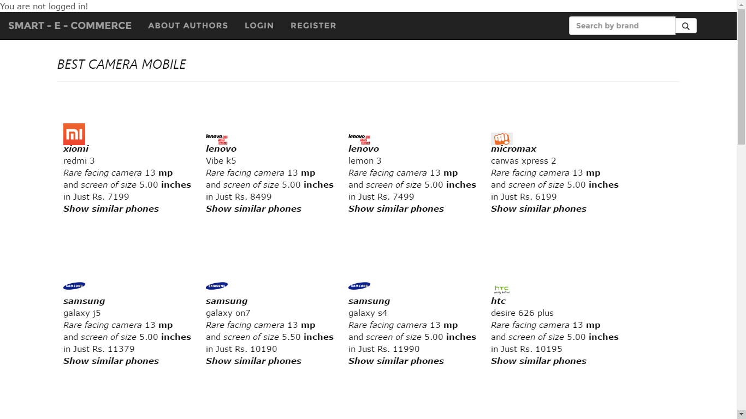

**Fig 3.1. Front Page**

**3.2 Registration Page :**A user registers on my site using this page. A glimpse of this page is shown beneath.The registration form is fully validated using a PHP script. Proper error messages are shown to help the shopkeepers during registration.

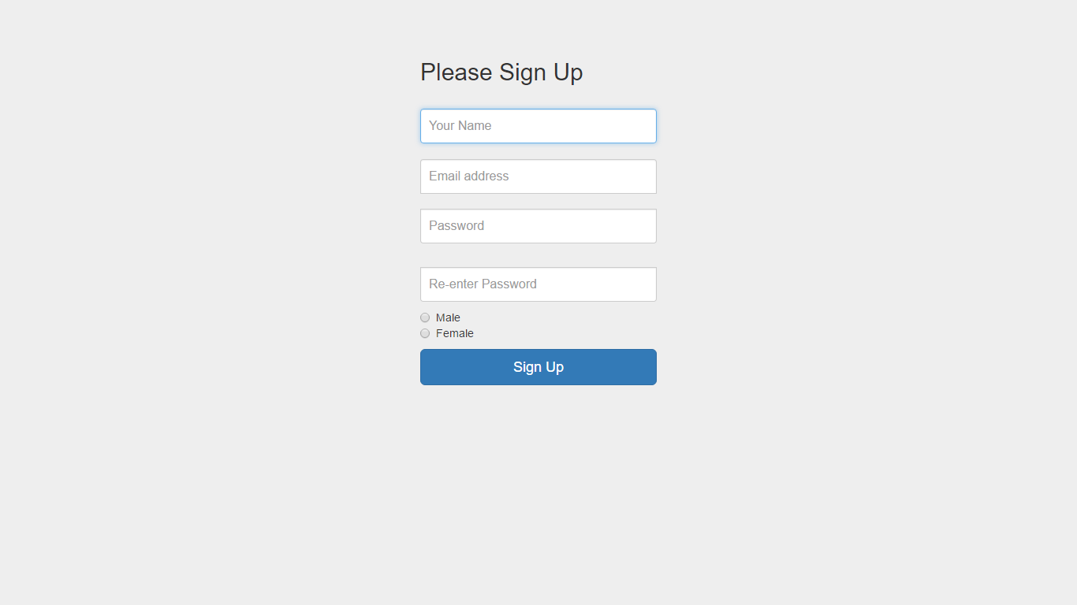

**Fig 3.2. Registration Page**

**3.3 Login Page :**A user login on my site using this page using his username and password. A glimpse of this page is shown beneath.The login form is fully validated using a PHP script. Proper error messages are shown to help the shopkeepers during login.

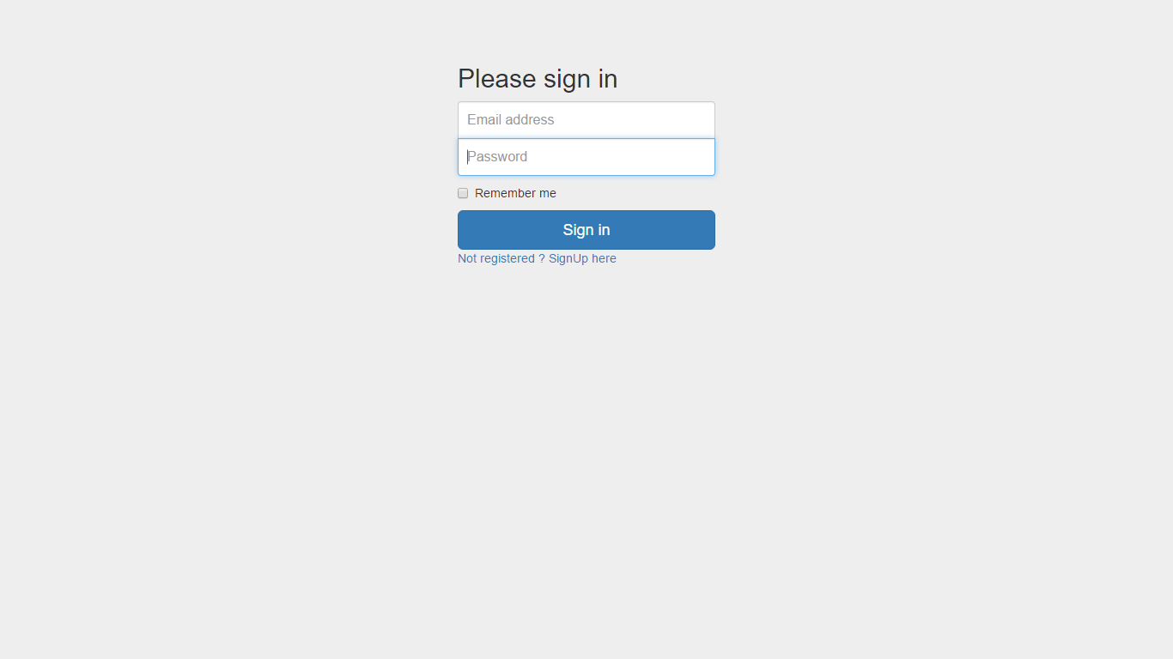

**Fig 3.3. Login Page**

**3.4 Navbar for Smart-e-commerce:**

Following are the content of navbar

**Without login**

**With login**



**3.5 Cart for user:**

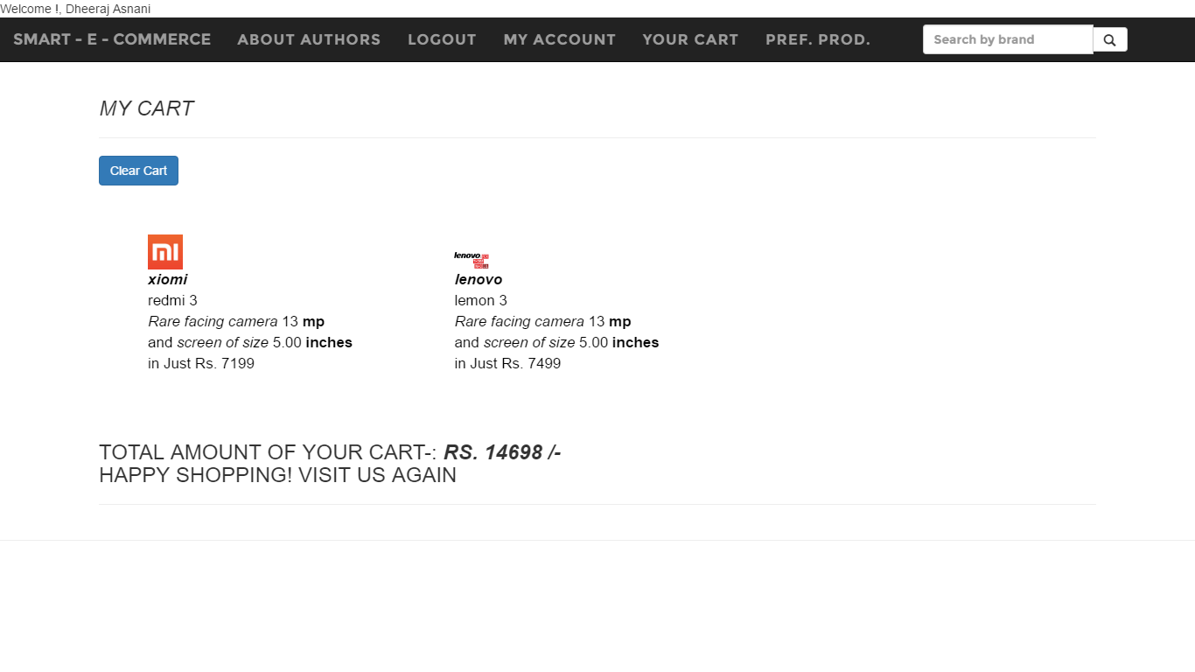

**Fig 3.5. Cart**

**3.6 Product description**

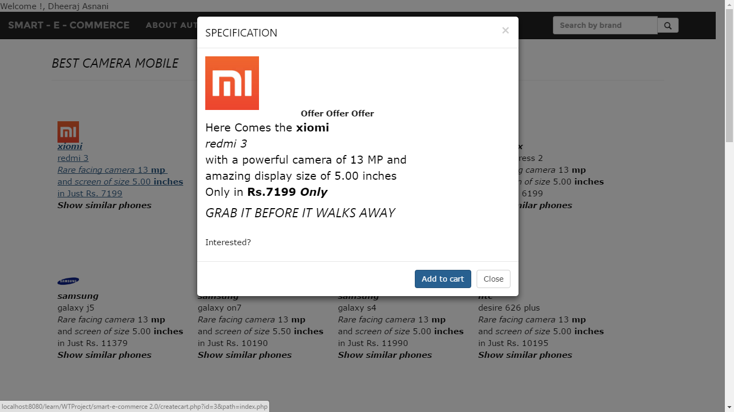

**Fig 3.6. Description of each product**

**4. Databases Used**

We have used following databases in our website to ensure proper display of result and products.

1. **MobileDB** DB contains the info about all the products available,

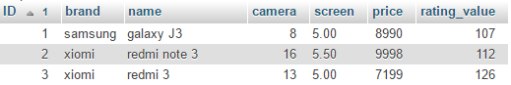

2. **Login details** DB contains information about all the registered users



3. **brand_value_map, camera_value_map, screen_value_map, price_value_map:**

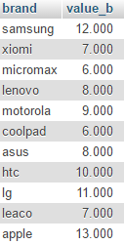

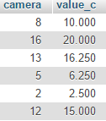

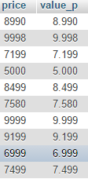

**5. Important PHP files:**

**5.1 DB connection php file:**

Help to connect to DB

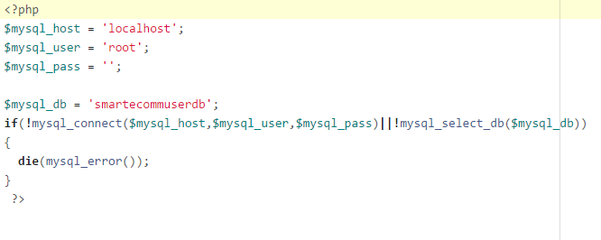

**5.2 Registration php file:**

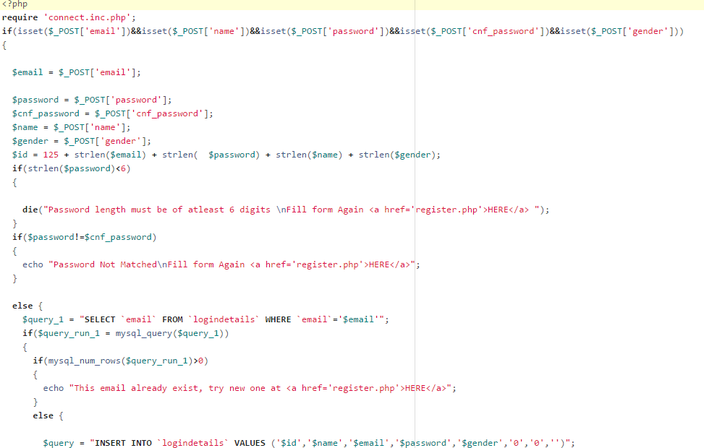

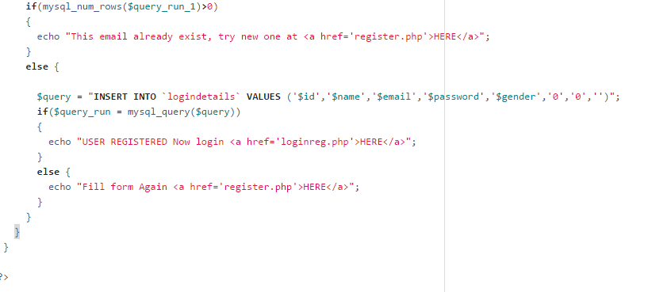

**5.3 Login php file**

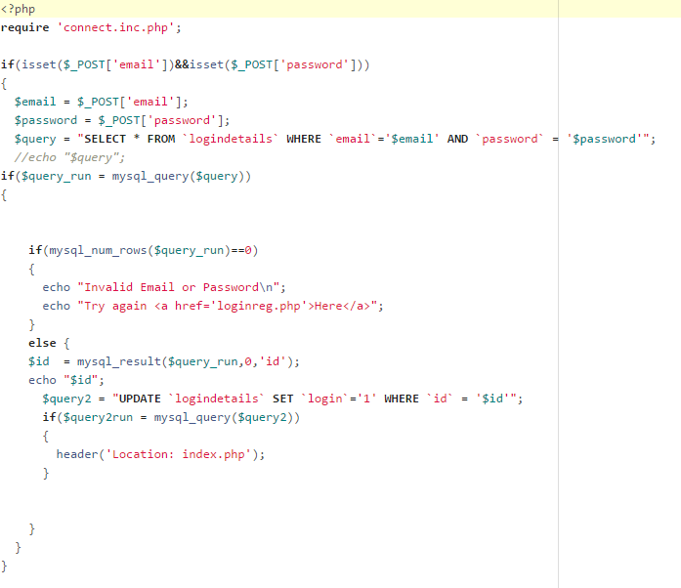

**5.4 Cart php file:**

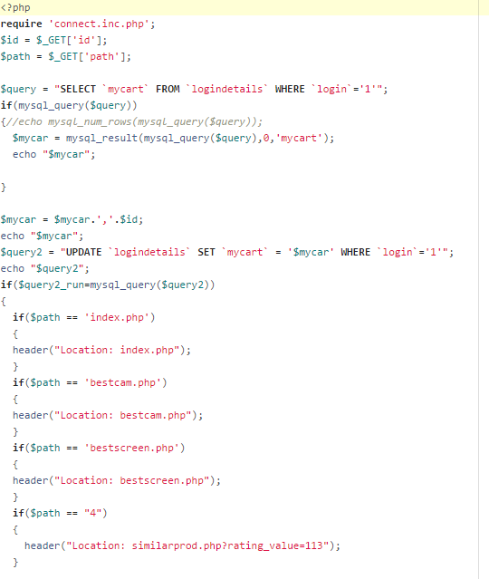

**6. Recommendation Formulae:**

For making user to know about their preferring products, we have created a equation for finding out the Item liked by user.

Let B be the value of brand form brand_value_map , C be the value of brand form camera_value_map , S be the value of brand form screen_value_map and P be the value of brand form price_value_map

For preferring products we have find a rating value R for each item

R = B*C*S/P

The motivation for this is that user always wants great features in LOW price, and price has been inverted in this calculation, The formulae can be improoved to new extents.

**7. Conclusion:**

In order to complete our website with specified task, we first have to start with creating a large database, maintaining it, analyze that data to predict the customer behavior and so as to achieve our task.

Our task for this project is to create a better system for making e-commerce experience better. Our problem attract us to use the systems like recommendation system but there are still many systems which can help us achieving the task.

A good way to boost your sales is by showing customers product that they may be interested in. This is called a recommendation system and can work in a number of ways. It’s a good idea for your website to display products that customer has previously viewed, so they can get back to them easily. The products a customer can be used to infer others they may be interested in. Data on what previous customer have bought gives your website a further way of recommending items.